SiteSage Progress Report
Guan Zheng Huang
Yaowen Liu
word-count: 993

1. Introduction
Entrepreneurs in traditional markets often struggle with evaluating optimal business locations, a challenge that can significantly impact success. Expert analysis in site selection can mitigate these risks, but such services often require customization and thus are expensive. SiteSage addresses this need by automating the evaluation of retail locations based on a user query containing:
- An address and
- a description of the store concept.
It returns:
- A quantitative score summarizing location attractiveness, and
- qualitative explanations (pros/cons) grounded in real-time data.
SiteSage is designed to support comparisons across multiple candidate locations.

2. Input / Output Definition

User Input:
A single user query in natural language containing:
- A Location (address/coordinate) and
- Store Description
  - May include: store concept (e.g., Coffee store),
  - Specialty notes (e.g., “take-out only”, “boutique roastery”),
  - Other information or business idea (e.g., “premium”, “small size”),
Example Minimal Input:
- A coffee shop on No. 288 Wuning Road, Shanghai

System Output: Multiple reports
- Three intermediate per-factor reports: customer, traffic, and competition analysis reports.
- Final weighted scores and explanation report: one score summarizing the overall attractiveness of the location and corresponding justifications.
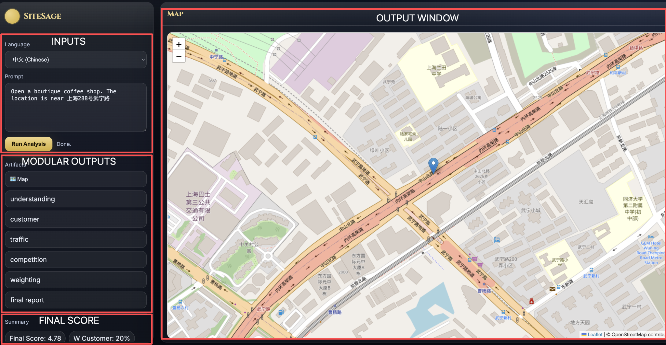
Figure 1. System UI demonstration
Fig. 1 demonstrates the current UI. Appendix: Execution Result outlines an example execution and sample reports.

3. Data and API

General API
- AMap LBS API: geocoding, nearby POI search, maps, distance calculation.
- WorldPop China: age-stratified population density rasters.
- Web Search API: open-web retrieval.

Evaluation Data
Shown in Fig.2 are 6 months of Dianping Reviews histories for 11 coffee shops from two brands (Starbucks and %Arabica). Review counts differ substantially by location, with stable relative differences despite monthly fluctuations, suggesting review volume is a reasonable proxy for visitor traffic. For interpretation: Appendix: Review count graphs interpretation.
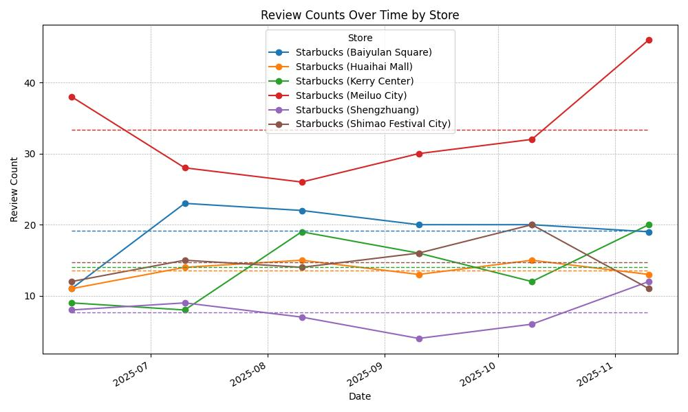
- Review count trend for Starbucks
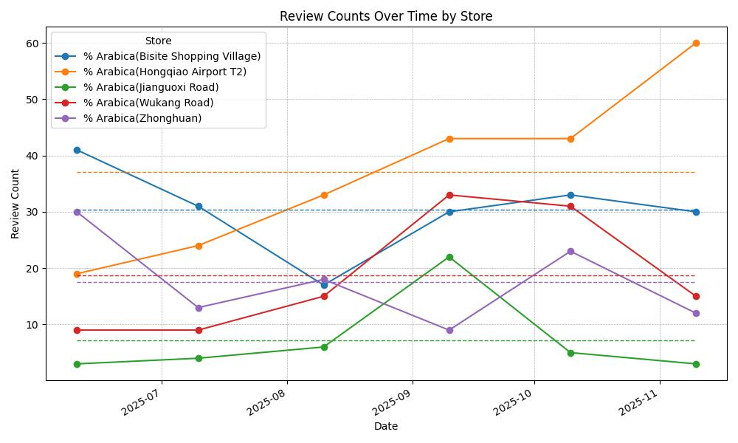
- Review count trend for Arabica
Figure 2. Visualization of evaluation data. Dashed lines = average

4. Determine Success

Methodology
We measure whether SiteSage can correctly rank which of two locations has higher visitor traffic with Evaluation data outlined above.
- Ground truth: We rank stores based on the average number of reviews in the past six months. A higher number of reviews is assumed to correspond to higher traffic; therefore, the store with more reviews is ranked higher.
- SiteSage prediction: We provide a basic prompt to SiteSage to evaluate each of the two locations. The store with the higher final attractiveness score is predicted to have higher traffic.

Metrics
- Accuracy: fraction of store pairs ranked correctly.
  - $\frac{\# correctly ranked pair}{n}$
- Average score margin: average of the difference in final predicted scores between pairs.
  - $\frac{1}{n}|\sum_{i=0}^{n}{}(score_a_{i}-score_b_{i})|$
See Appendix QnA for a change-log since the proposal and rationale behind metrics selection.

5. Software Structure
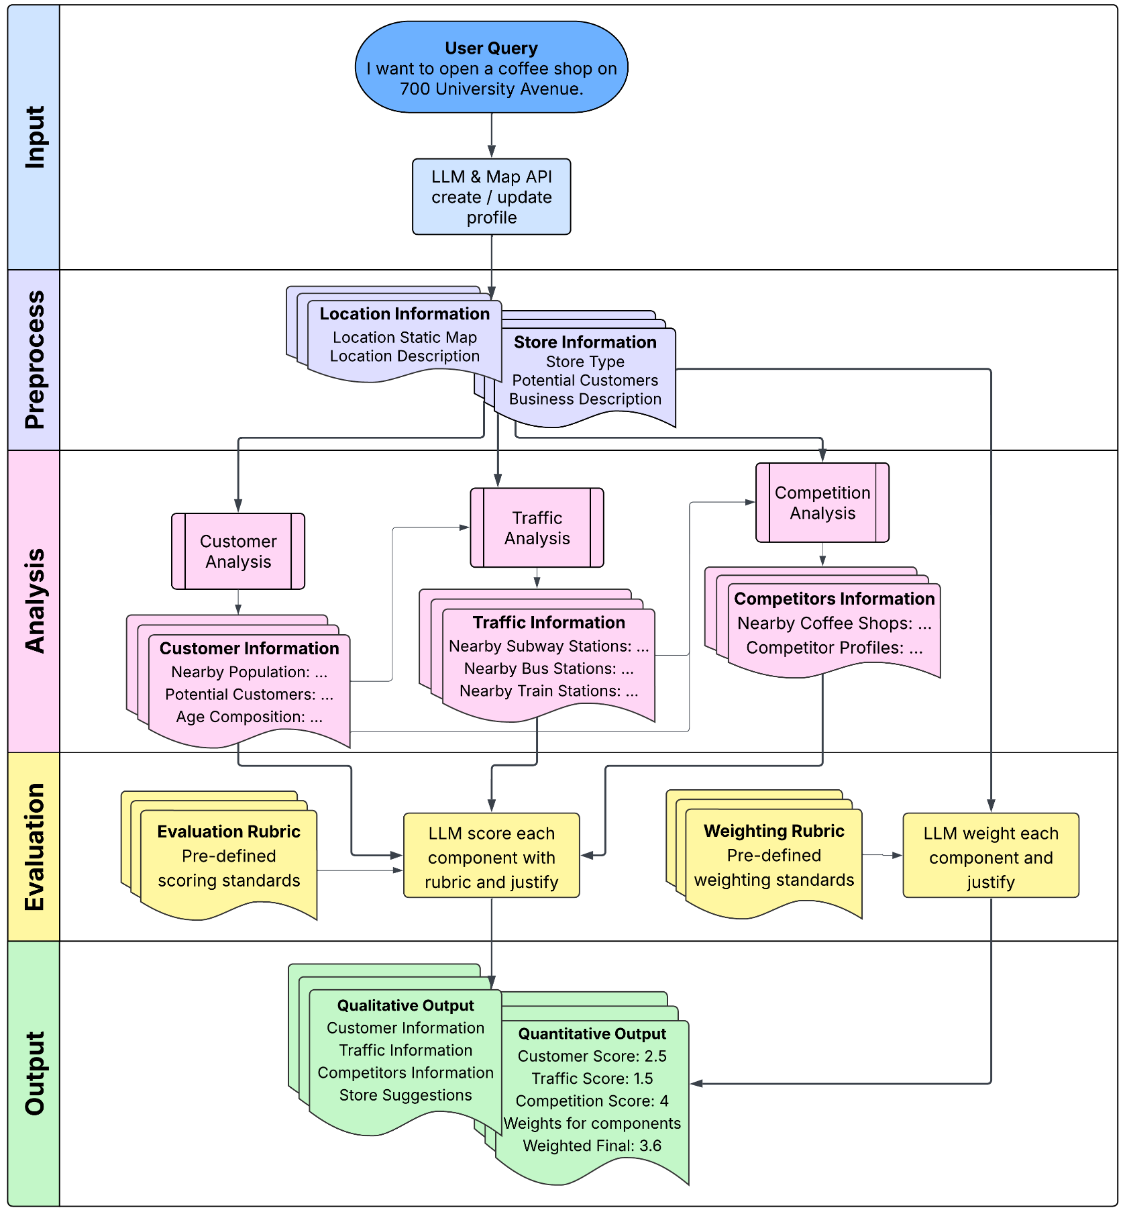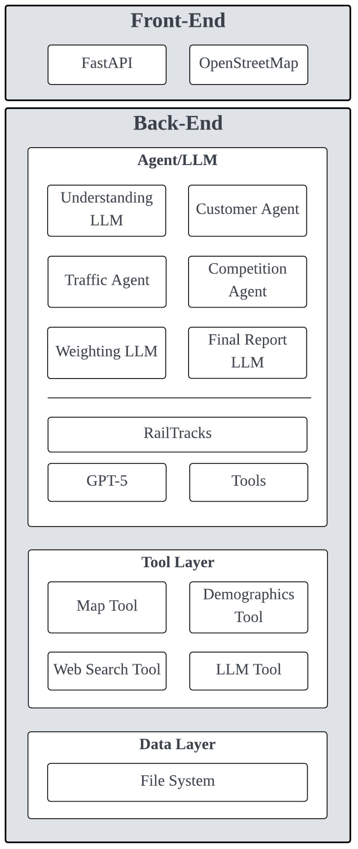
Figure 3. SiteSage Workflow and Software Structure

Front-End
- Input for the user query.
- Panels to display intermediate factor reports and final score report.

Backend
The execution follows a linear sequence outlined in Fig. 3
- Understanding LLM parses the query and extracts the location and description.
- Weighting LLM generates per-factor weights (customer/traffic/competition) and explanation using a rubric inspired by Huff’s gravity model. This step is separated from scoring to eliminate bias that may future during analysis phase.
Agents: Each factor-analyzing agent writes a structured report (facts + interpretation) that becomes context for subsequent agents.
- Customer Agent: uses AMap + WorldPop to estimate local population density and demographics.
- Traffic Agent: queries transit POIs and road infrastructure.
- Competition Agent: finds nearby comparable stores and summarizes competitors.
- Final Report LLM: Multi-staged prompt
  - Computes per-factor scores based on factor reports and rubric.
  - Applies generated weights.
  - Outputs an overall attractiveness score with explanation for factor and weight (final report).

Tool Layer
Provide standardized interface for API/data query. Use by all factor-analyzing agents:
- Map Tool (AMap),
- Demographics Tool (WorldPop),
- Web Search Tool,

Data Flow
In Fig 4. (Appendix: Sequence Diagram File), we present a simplified sequence diagram outlining module interaction and information flow.
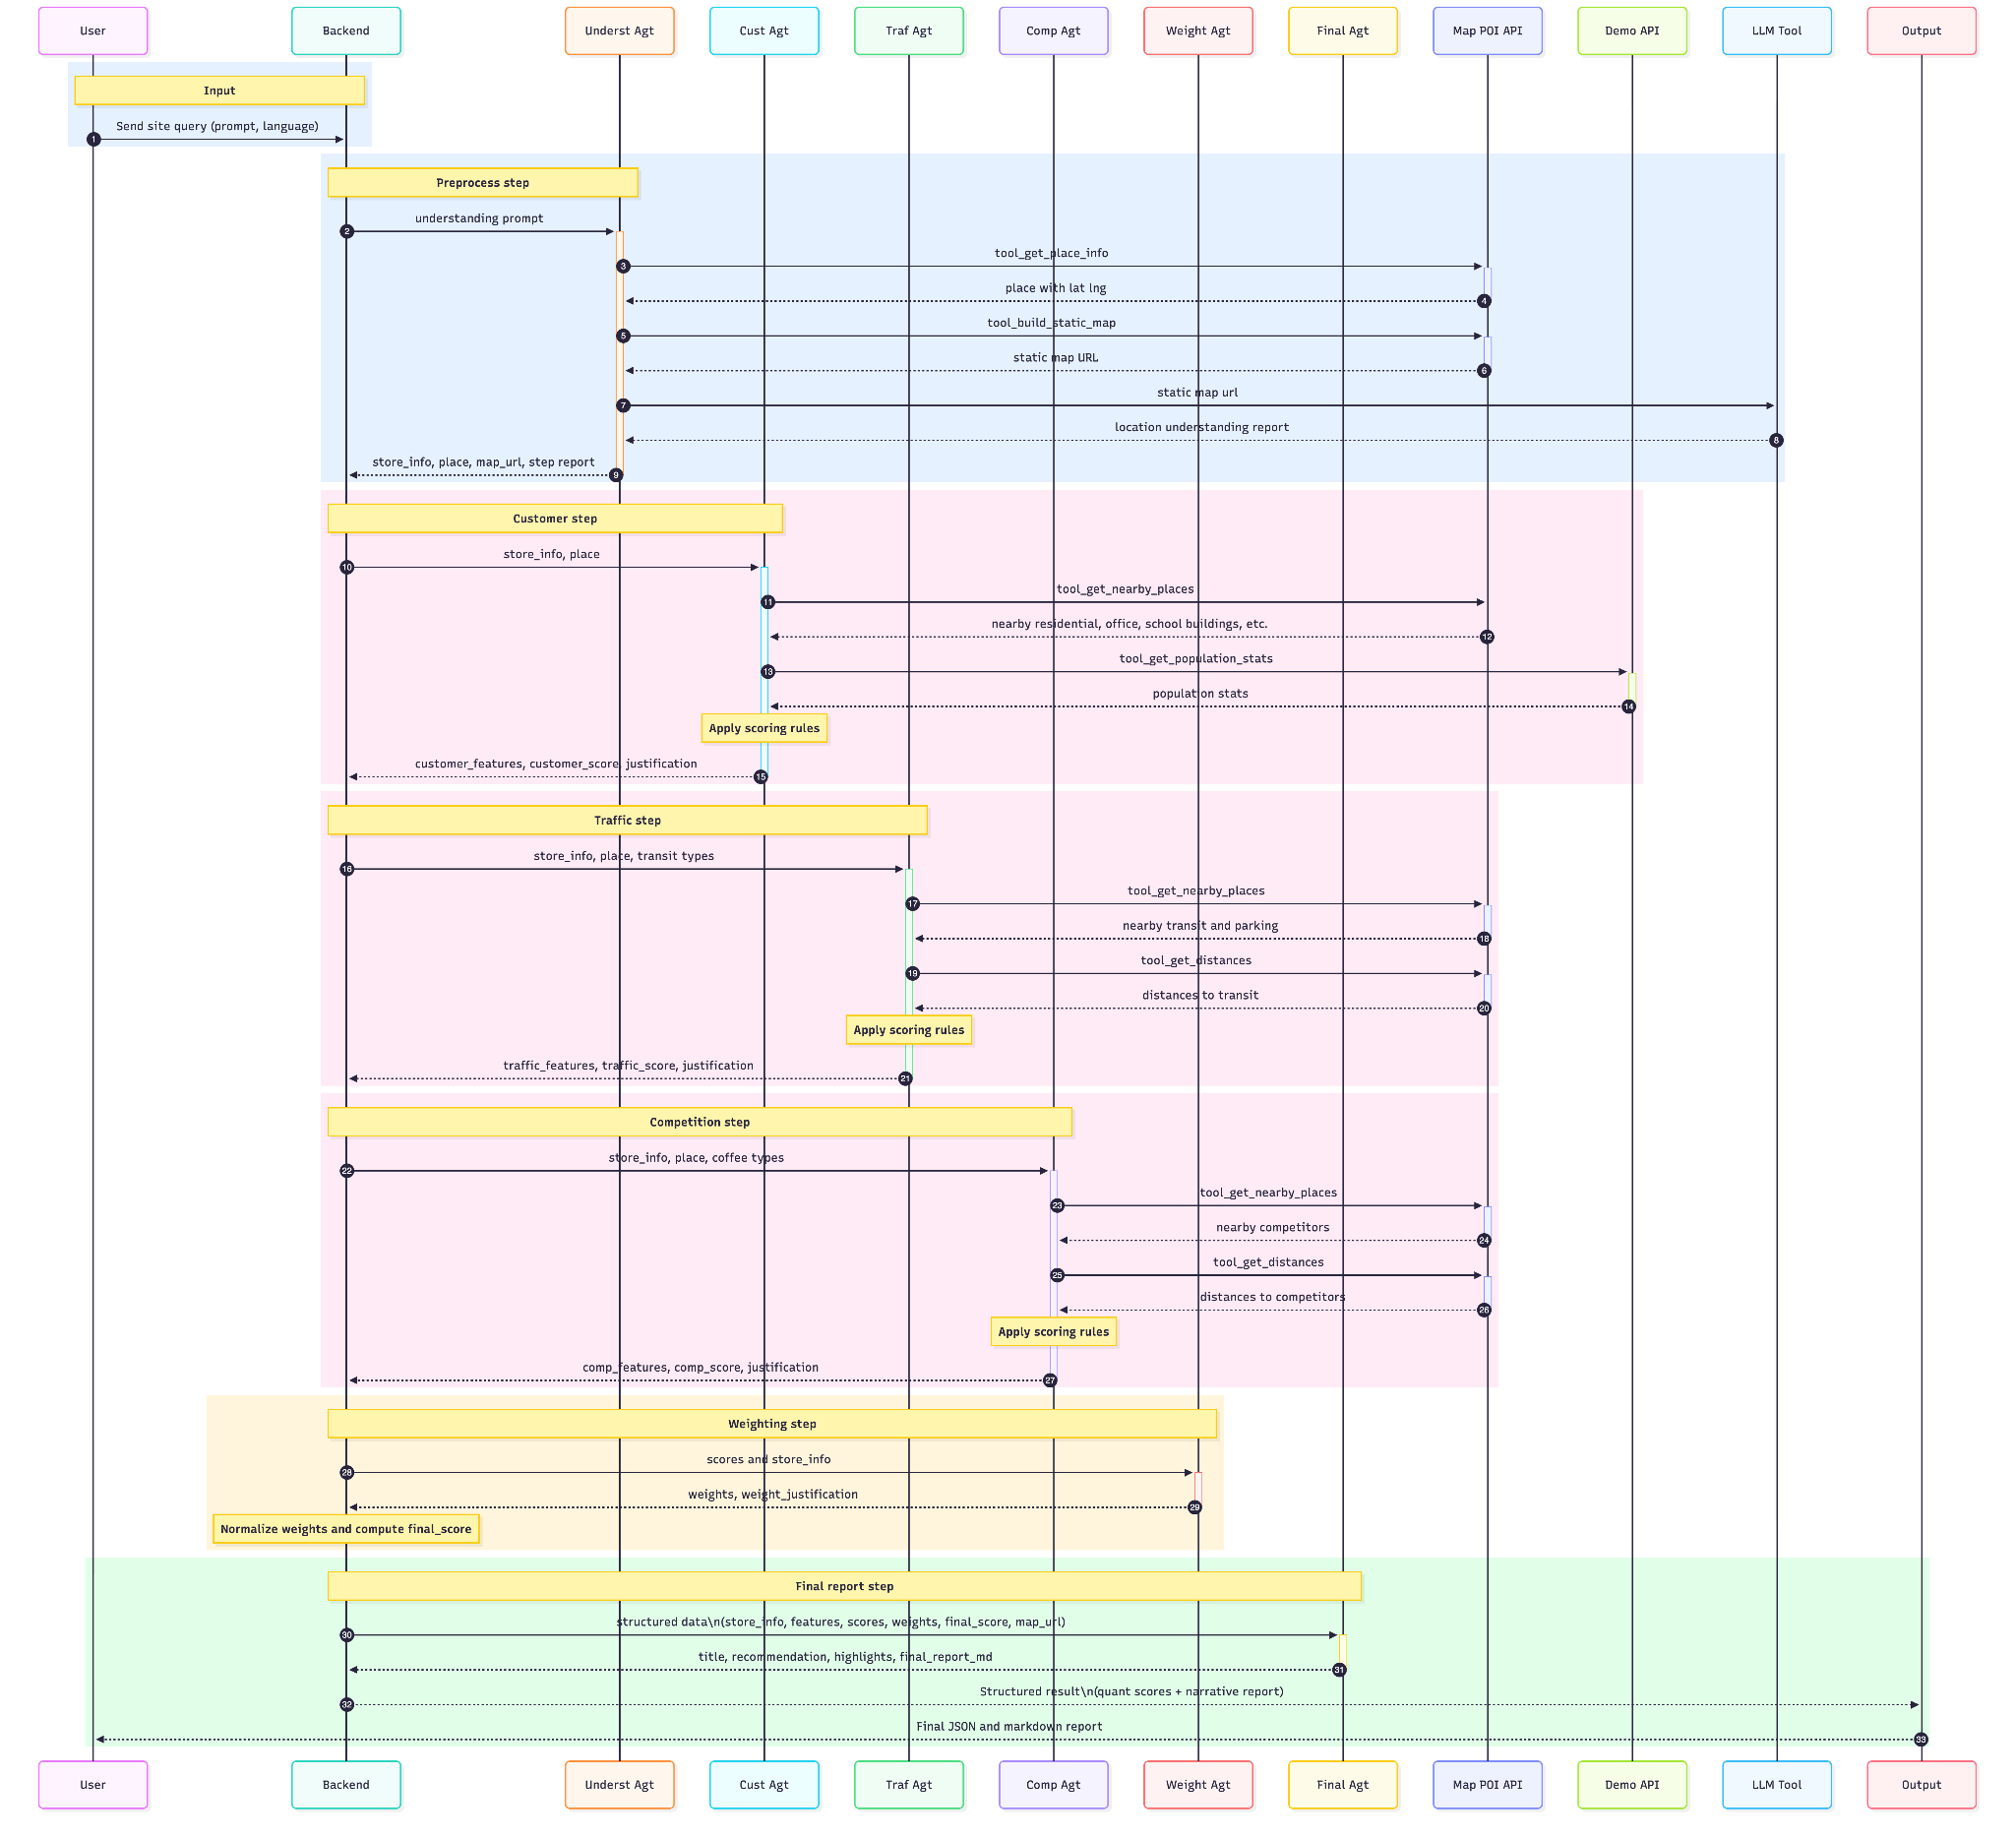
Figure 4. SiteSage simplified sequence diagram

Progress
- All designed are implemented.

6. Result

Evaluation
We formed 25 same-brand store pairs (6 Starbucks, 5 Arabica) with similar sizes and opening times. Using 6-month average Dianping review counts as ground truth:
- Initial Accuracy (15/25): 0.60
- Average score margin: 0.61
See Appendix: Pair Evaluation for an example comparison.

Comparison with single prompt
We gave an LLM access to the same tools but asked it to perform the entire analysis in a single prompt: Appendix: Single Prompt prompt.
- Accuracy: 0.52
- Average score margin: 0.3
SiteSage is both more accurate and more discriminative. Poor single-prompt performance may arise from the task's complexity assigned in a single request.

Comparison with single agent
We gave an LLM access to the same tools and staged-prompts as SiteSage. However, instead of creating a new conversation for each task, we allowed the memory to persist across stages (analysis, weight, customer, traffic, competition, and summary).
- Accuracy: 0.48
- Average score margin: 0.37
We observed that early, possibly mistaken impressions about a location tended to bias later stages, yielding less thorough analysis later on.

7. Discussion
SiteSage outperforms random guess (0.5) and both alternative implementation on pairwise ranking accuracy. Its qualitative outputs reference concrete POIs and demographic facts, which align with our design goals.
Beyond the risks outlined in the proposal and Appendix: Risks, we found that even with a carefully crafted weight-designing rubric, the generated weights can be somewhat inconsistent. We will provide examples for the LLM (shots) to improve consistency.
Appendix: Q&A contain responses to common concerns and questions about SiteSage. Appendix: Future Consideration contains the next step discussion.

8. Team Work and Progress
- Yaowen leading: Data pipeline, ground-truth collection, rubric design, tool development.
- Guan leading: Tool integration, agent architecture, scoring and reporting modules, frontend.

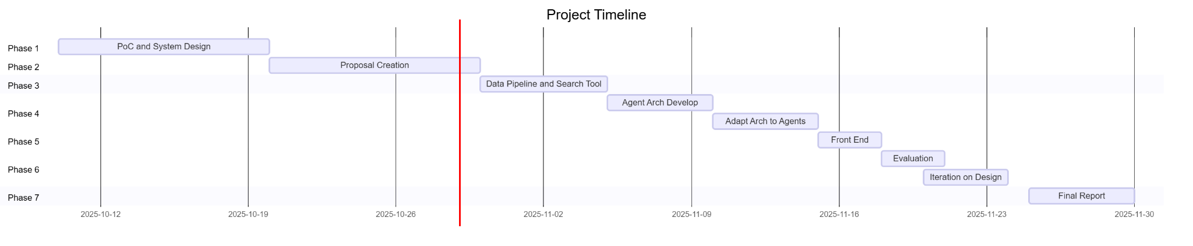
Figure 5. Project development waterfall
As illustrated in Fig 5., we remain on track to prototype, implement and evaluate SiteSage. The collaboration is smooth, and all code to date has been committed to: ece1786-2025/SiteSage.

Appendix: Execution Result
- Input: Open a boutique coffee shop with a cozy vibe targeting young professionals and students. Strong morning traffic is desired. The location is No.1515 Nanjingxi Road, Kerry Center e1-03.
- Progress report for verification:
  - Structured Location Context
  - Location: 121.449648,31.224239
  - Description: The user's request involves opening a boutique coffee shop at No.1515 Nanjingxi Road, Kerry Center e1-03. The target customers for this coffee shop are young professionals and students, with a strong emphasis on attracting morning traffic. The location has been geocoded to a specific entry point at the Jing'an Kerry Centre on Nanjing West Road in Shanghai.
- Output:
  - Customer report: https://github.com/ece1786-2025/SiteSage/blob/main/docs/ProgressReport/01_customer_report.md
  - Traffic report: https://github.com/ece1786-2025/SiteSage/blob/main/docs/ProgressReport/02_traffic_report.md
  - Competition report: https://github.com/ece1786-2025/SiteSage/blob/main/docs/ProgressReport/03_competition_report.md
  - Weighting report: https://github.com/ece1786-2025/SiteSage/blob/main/docs/ProgressReport/04_weighting.md
  - Evaluation report: https://github.com/ece1786-2025/SiteSage/blob/main/docs/ProgressReport/05_evaluation.md
  - Final report: https://github.com/ece1786-2025/SiteSage/blob/main/docs/ProgressReport/06_final_report.md
  - Final Score: 7.8/10
    - Customer Analysis (Score: 9.1/10)
    - Traffic & Accessibility (Score: 8.3/10)
    - Competition Landscape (Score: 5.5/10)

Appendix: Review count graphs interpretation
1. %Arabica Store Trends
- Hongqiao Airport T2 is the top performer, rising from ~20 to ~60 reviews/month.
  - Pattern: strong upward trend, highly sensitive to travel peaks.
  - Interpretation: Airport foot traffic dominates performance—location advantage is overwhelming.
- Bisite Shopping Village starts strong (~40) but declines sharply to ~17 before stabilizing around 30.
  - Interpretation: a shopping-outlet-type seasonal effect.
- Wukang Road grows steadily (from ~8 → ~32), then drops again.
  - Interpretation: this is a tourist corridor, probably influenced by tourism cycles or nearby events.
- Zhonghuan shows mid-level stability with some fluctuations.
  - Interpretation: local residential + commuter flow.
- Jianguxi Road remains consistently low (around 3–22, peak in September).
  - Interpretation: weak foot traffic or overshadowed by nearby competitors.
2. Starbucks
- Meiluo City is the top performer (high 30s → almost 45) with some fluctuations.
  - Interpretation: high-traffic mall with steady growth.
- Baiyulan Square shows moderate consistency (20–23 range).
  - Interpretation: reliable professional district flows.
- Other stores (Huaihai Mall, Kerry Center, Shengzhuang, Shimao Festival City) show stable but mid-range performance (10–20).
- Shengzhuang displays long-term low performance (5–11) → likely suburban or low-visibility location.

Appendix: Pair Evaluation
Example Pair Evaluation
Location A: East Nanjing Road Starbucks
- Actual 180-day Reviews: 35
- Predicted Score: 7.1
Location B: Xujiahui Starbucks
- Actual 180-day Reviews: 21
- Predicted Score: 5.8
Outcome:
- Ground truth: A > B
- System predicted: A > B
- Result: Correct

Appendix: Single Prompt prompt
You are a commercial real estate site selection analyst evaluating a potential retail location. Given a business concept and location address, produce a comprehensive site suitability score (0-10) by analyzing:

**1. Customer Potential (Score 0-10)**
- Query population statistics within 300m, 500m, 1000m, and 1500m radius
- Analyze total population density and age demographics
- Match demographics against target customer profile
- Consider: Does the local population align with the target customer base? Is there sufficient foot traffic potential?

**2. Traffic & Accessibility (Score 0-10)**
- Search for nearby transit nodes: subway/metro stations, bus stops/stations within 500m-1500m
- Search for parking facilities within walking distance
- Calculate distances to nearest transit points
- Consider: How easily can customers reach this location? Are there multiple transportation options?

**3. Competition Density (Score 0-10)**
- Query similar businesses (same category) at multiple radii: 500m, 1000m, 1500m
- Count competitors at each radius
- Identify nearest competitor and its distance
- Consider: Is there healthy demand without oversaturation? Too many competitors = market saturation; too few = unproven demand

**4. Weighted Final Score**
- Derive domain-appropriate weights for customer/traffic/competition based on business type
- Example: Coffee shop might weight customer=0.4, traffic=0.35, competition=0.25
- Example: Premium boutique might weight customer=0.5, traffic=0.2, competition=0.3
- Calculate: `final_score = (customer_score × w_customer) + (traffic_score × w_traffic) + (competition_score × w_competition)`
- Normalize weights to sum to 1.0

**5. Executive Report**
Generate a markdown report containing:
- Executive Summary (final score interpretation, clear recommendation: "Highly Recommended" / "Recommended with Caveats" / "Not Recommended")
- Site Overview (address, neighborhood context, location description)
- Customer Insights (population metrics, age distribution analysis, target alignment)
- Traffic & Accessibility Analysis (transit proximity, parking availability, access modes)
- Competition Landscape (competitor density at various radii, nearest competitor distance, market positioning)
- Weighting Rationale (justify why specific weights chosen for this business concept)
- Risk Factors & Mitigation Strategies
- Actionable Recommendations (next steps, additional due diligence needed)
- Appendix (key metrics table)

**Tools Available:**
- `getPlaceInfo(address)` → geocode address to lat/lng coordinates
- `getPopulationStats(location, radius_m)` → population total and age breakdown
- `getNearbyPlaces(location, types, radius, pages)` → search POIs by category
- `getDistances(origin, destinations, mode)` → calculate distances/travel times
- `osm_static_map_url(lat, lng)` → generate map visualization URL

**Output Requirements:**
- All scores must be numeric (0-10 scale) with clear justification
- Use iterative tool calls (try multiple radii/parameters to gather comprehensive data)
- Weights must be non-negative and sum to ~1.0
- Final score must be a weighted average with 2 decimal precision
- Generate markdown reports at each step (customer analysis, traffic analysis, competition analysis, weighting rationale, final executive report)
- Include map visualization URL
- Provide concrete, actionable recommendations based on quantitative data

Appendix: Risks

ID | Risk Name | Cause | Impact | Mitigation
H1 | Internet Data Drift | Data available is not recent | Prediction may reference outdated results | Suggest recent result in prompt, rule-based filter.
H2 | Data Availability | Limited open data access | Incomplete analysis | Limit project scope, provide api access to the data source.
H3 | Generalization | Diverse business models | Difficulty to tune model across domains | Acceptable in prototype, more flexible structure if developed product
H4 | LLM Abilities | Intrinsic model constraints | Potential performance issues | Select more powerful models, evaluation to detect issues.
H5 | Hallucination | LLM limitation | Misleading results | More powerful models, RAG and force reference generation.
H6 | User input accuracy | The context provided is not detailed | Poor search and result performance, too general. | Educate users on effective input or provide more granular-entry fields.

Appendix: Q&A

Evaluation Question
What changed in the metric of success between the proposal and this report?
- Our evaluation method largely aligns with the proposal, with two key refinements:
- We will use average review data from the past six months (the longest period provided by the Dianping API) instead of one month, to reduce variance in the ground-truth data.
- We will omit the evaluation of MAE, as SiteSage is not designed to predict the actual number of visitors. Instead, it provides an abstract score, making comparisons with visitor ratios unfair.
Can you give me an Example of an evaluation run?
- We sampled two Starbucks locations: Location A received 100 reviews and Location B received 50 reviews in the past six months. According to the ground truth, Location A is more popular than Location B.
- We ran SiteSage on each location individually, producing scores of 9.0 for Location A and 5.0 for Location B.
- Since our prediction that Location A > Location B aligns with the ground truth, we consider this comparison successful.
What prompt do you use for evaluation?
- To reduce complexity and to serve as a baseline, we will use: “A coffee shop at {location}” as the prompt. In a realistic usage scenario, we encourage the user to provide a more descriptive business plan, such as the intended store style or budget for renovation. The LLM should be able to produce a more considerate and accurate estimate of store traffic.
Are the metrics of success too simple?
- The current metrics of success lack consideration of many aspects, such as store renovation, staff, strategy, promotions and other external factors that influence review. However, the metrics serve as a simple evaluation and an effective evaluation when completed in large quantities, with the hope that it will average out individual store differences. Especially, if the final evaluation achieves a high accuracy, it serves as strong evidence that SiteSage performs beyond a random guess.
When comparing the backward-in-time location of an existing coffee shop, it's essential to know what information was available at that time for an accurate judgment. Is this possible?
- Indeed, it is possible. Using search engines like Google, we can set the search date for more relevant results. Review APIs allow data collection per month, and the same goes for demographics. However, we cannot enforce this behaviour on websites. For example, in a forum, even if the post is old, comments may be more recent. Regardless, we did not enforce a time-cutoff in data for numerous reasons, primarily because we are interested in factors driving the store’s current traffic compared to when it first opened.
- It should be noted that for historical data, we rely on the LLM’s ability to understand which data range is more relevant and allow it to determine the time range in tool calls. LLMs can distinguish which data is too distant and are instructed to ignore such information.
- For example, if we collect data before a store first opened and evaluate a score based on this data, it will not reflect the system's current performance. Comparing two stores across time scales is also controversial. The review numbers in the first couple of months when the store first opened may be influenced by many factors, such as the popularity of the review tool at the time, social trends, and seasonal information. While the LLM is likely to adjust weights based on this information, it adds complexity and questions the validity of the metrics. We believe there are easier and more accurate methods.
For evaluation, if you are not using historical data, what are you comparing instead?
- Instead of using historical data, we compare recently opened stores of similar size and brand, enabling easy comparisons with a consistent time scale. For instance, in January 2025, over 30 Starbucks opened in Shanghai out of 300+ total coffee shops. This data is more than enough to support our analysis.
For evaluation, have you tested it?
- We have not yet experimented with the time-cutoff approach. We will evaluate the model's performance in the final report as an extended experiment.
For evaluation, can the model cheat and read review numbers?
- Based on our inspection, no search result other than paid review APIs contains this information. The most LLM can access with opne internet search are segments of recent reviews, not review counts, which is not a major concern. In a developed product, these risks should and can be addressed. However, for our prototype, we deem the influence acceptable under monitoring.
Why China, why Shanghai, why coffee stores for evaluation?
- Various APIs, such as DianPing and Demographic in China, are free to access and easier to set up.
- We chose Shanghai as it's a big city.
- We chose coffee stores for the store number, ease of understanding, familiarity, and rather intuitive traffic-to-revenue mapping.
- We selected one business type and one region in particular to obtain comparable scores using the same set of APIs. It somewhat eliminates API/tool differences, as well as regional differences. For instance, comparing across Dianping, Google Review, and Yelp would not be fair due to platform popularity being different across regions.
Is the system transferable to other business types or cities?
- The Google review API is a paid service similar to Dianping Reviews.
- Demographics and income data likely exist per country.
- In terms of design, SiteSage does not have any form of hard-coding for store type or location preference, so it should be transferable.

General Question
What data is the output based on?
- Beyond demographics and maps, the LLM can query any data it desires on the internet. Based on inspection, it prefers looking at:
  - Nearby infrastructure
  - District reputation (how developed it is)
  - Local forums
  - Competitor details (review, popularity, age, etc.)
  - Attractions ("[neighborhood name] events," "[neighborhood] nightlife," "[neighborhood] tourist attractions.")
  - Parking
  - Property value (using property value to reflect traffic, not operation cost)
Why are you not using Google Mobility Reports, OpenStreetMap, or City Data APIs to enhance the accuracy of customer traffic estimation?
- We chose a small system with limited tools since it is a prototype; it is relatively easy to expand the list of accessible tools.
Why not incorporate time-based traffic patterns?
- We are interested in general traffic (over months) instead of days of the week. We believe this information is more important for site selection, a decision with long-term impact.

Appendix: Sequence Diagram File
https://drive.google.com/file/d/1H_Y0llGnfxBZXJb-f-XT9ux73VZLAJuU/view?usp=sharing

It should be noted, for ease of reading, that the sequence diagram is simplified. It does not demonstrate loops, stop conditions and if-statements.

Appendix: Future Consideration

- Improve the weight-generation rubric with stricter constraints.
- Iterate on prompt design based on failed cases surfaced from evaluation.
- More Evaluation and data collection
- Expand the ground truth dataset to 40–50 pairs to stabilize variance.
- More same-brand coffee shops in small geographic areas for fine-grained comparison.
- More same-brand locations across the city for generalizability.
- Additional retail categories for qualitative testing.

